PCA-SIMS Spectra Analysis Report

**Soil Carbon Cycling/Lignin**

ToF-SIMS testing date: 20220401/20220422

ToF-SIMS operator: Zihua Zhu

# 2D PCA scores plots

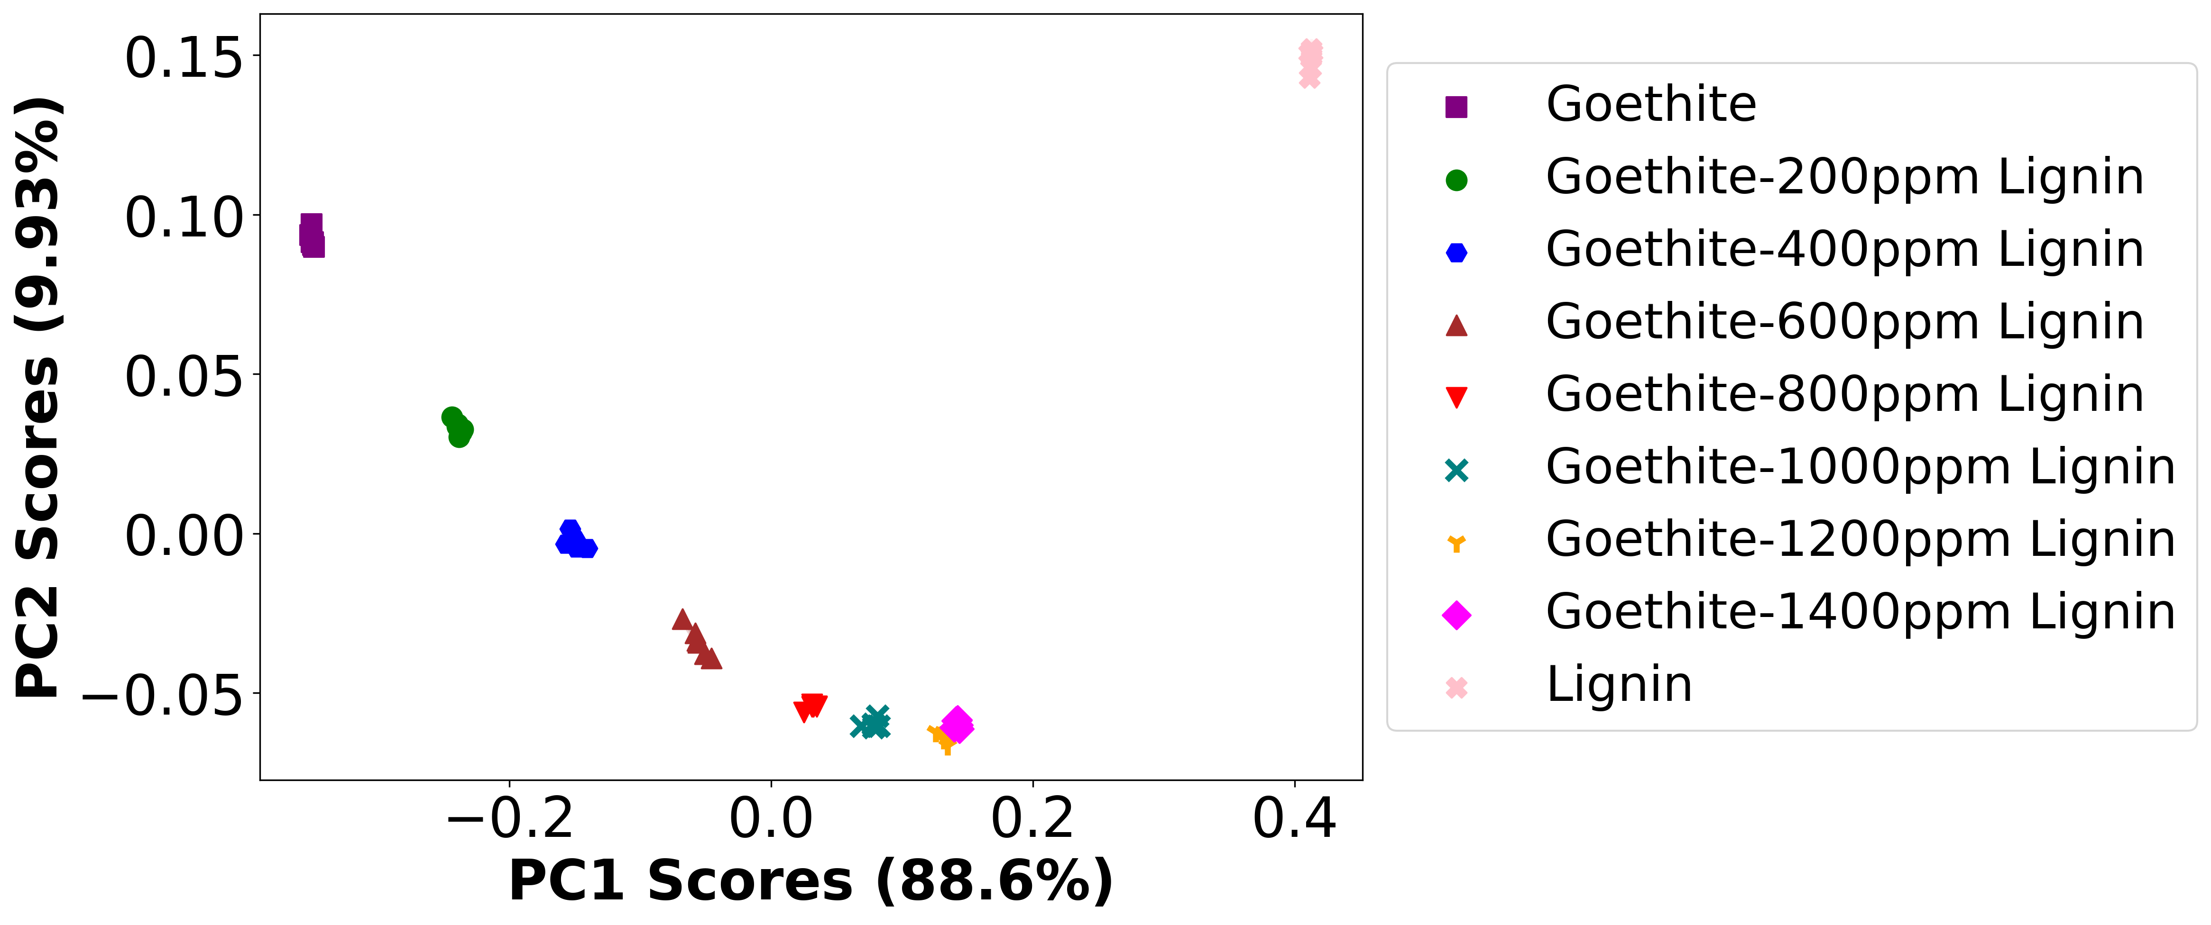

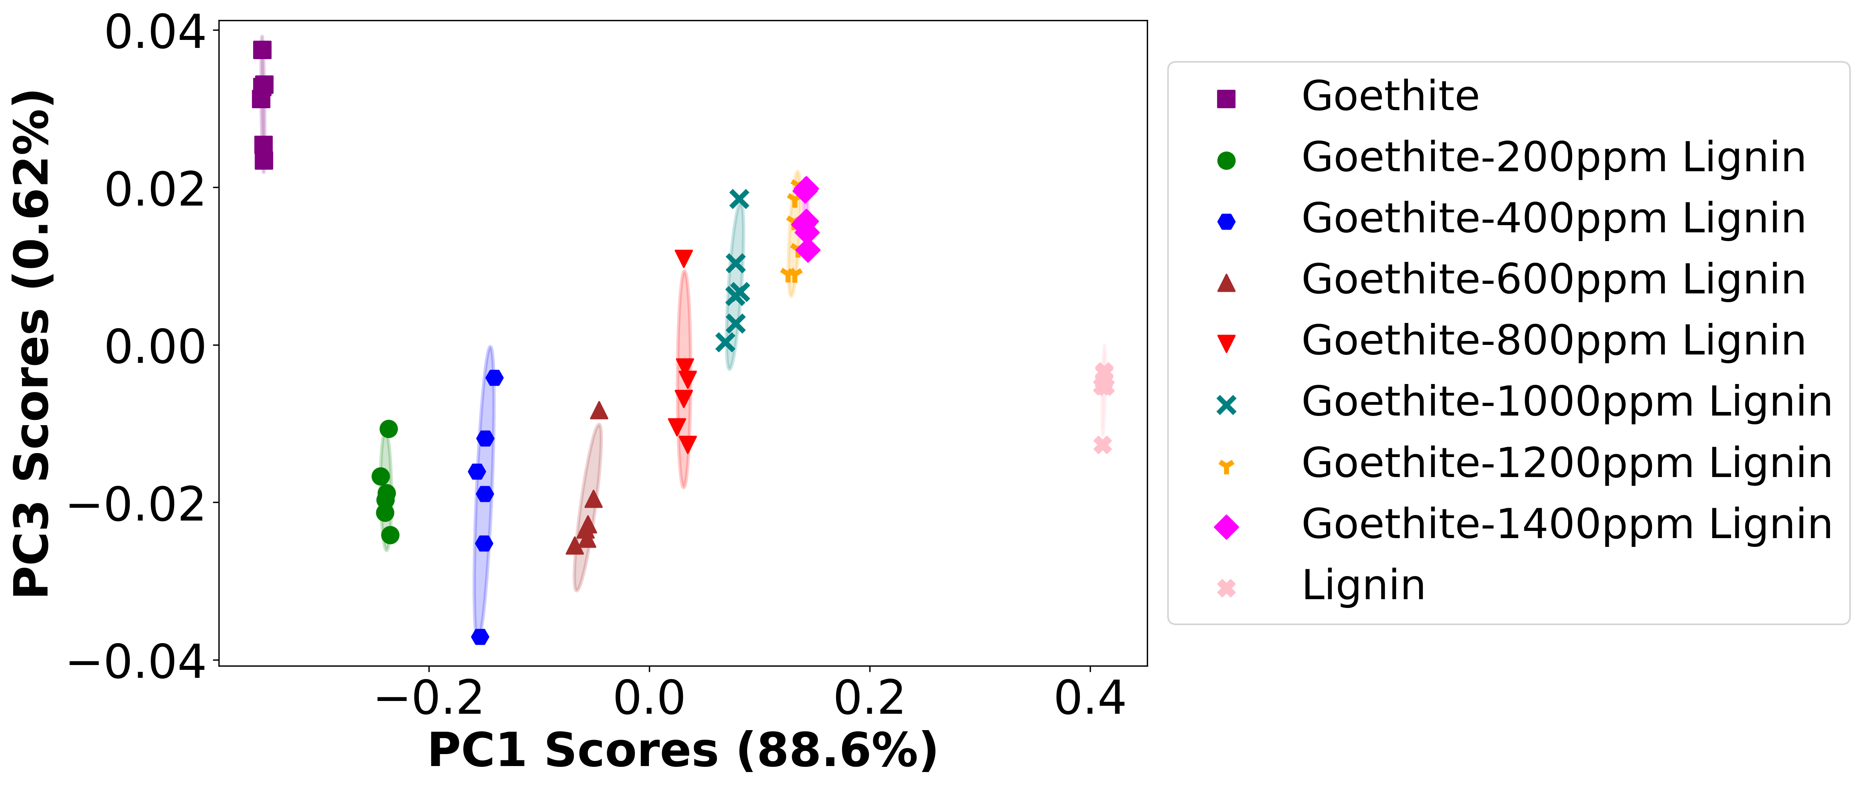

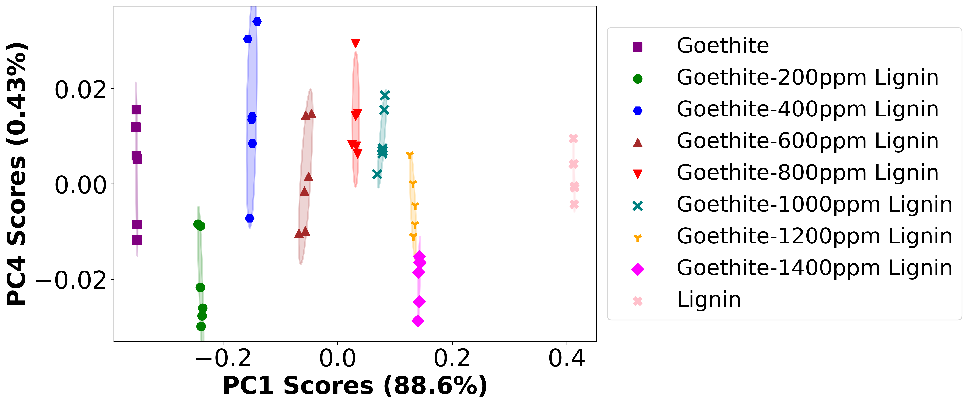

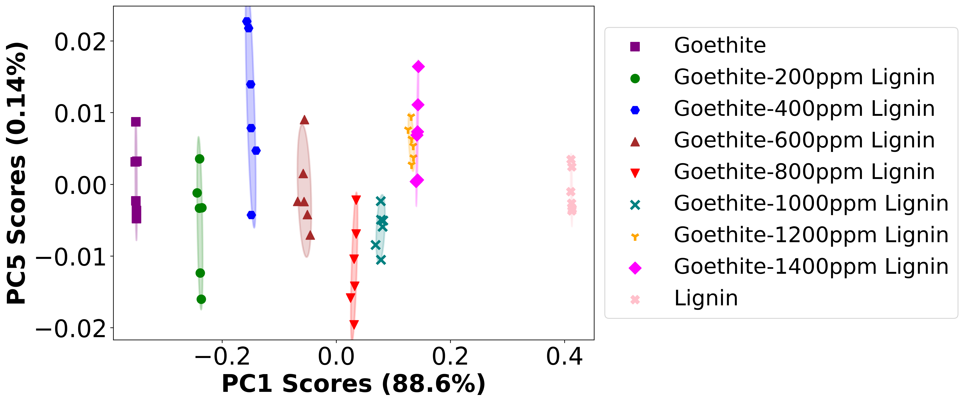

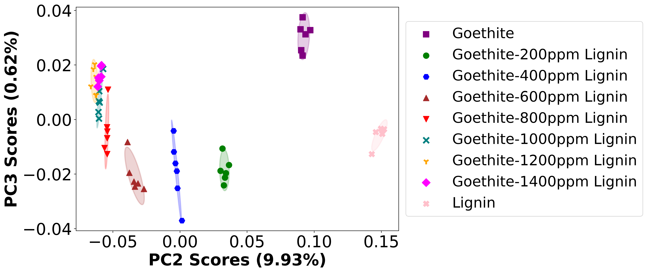

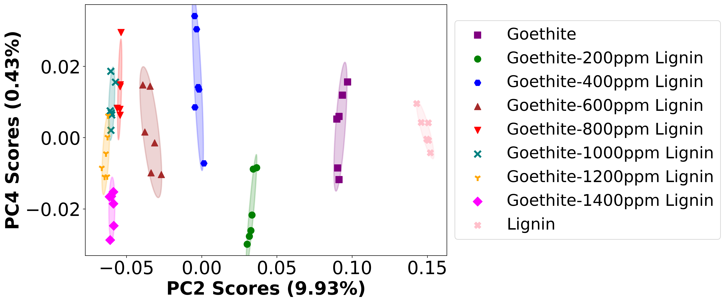

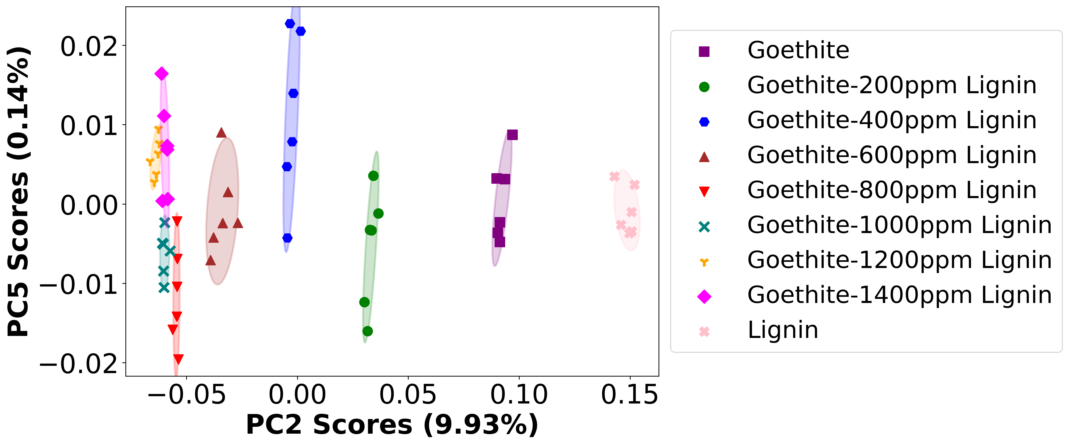

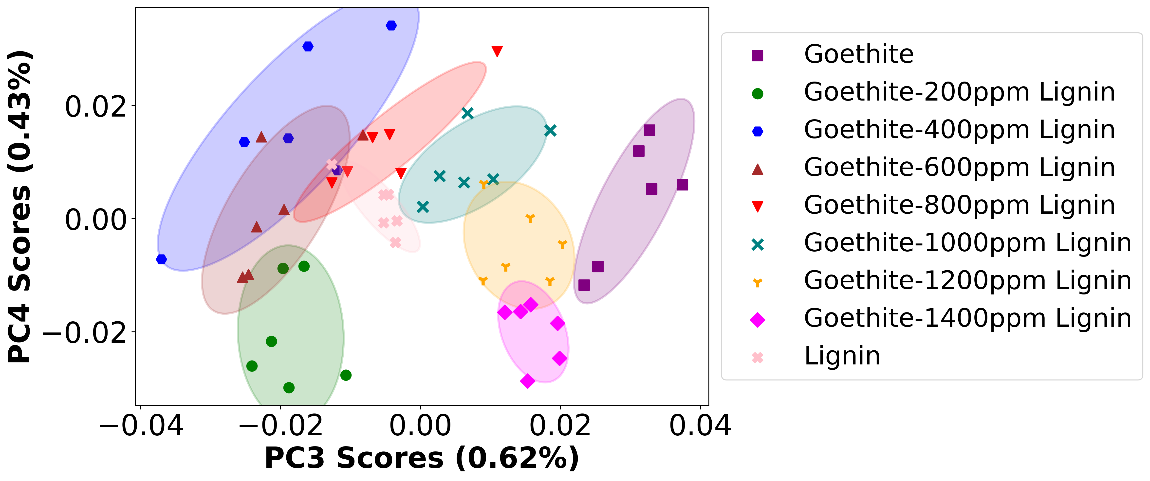

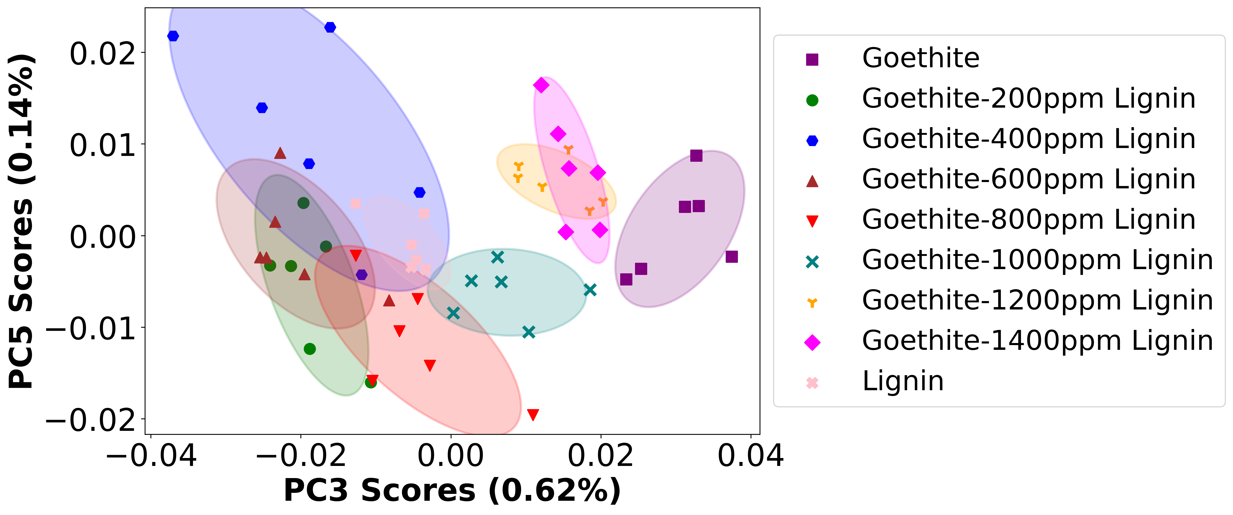

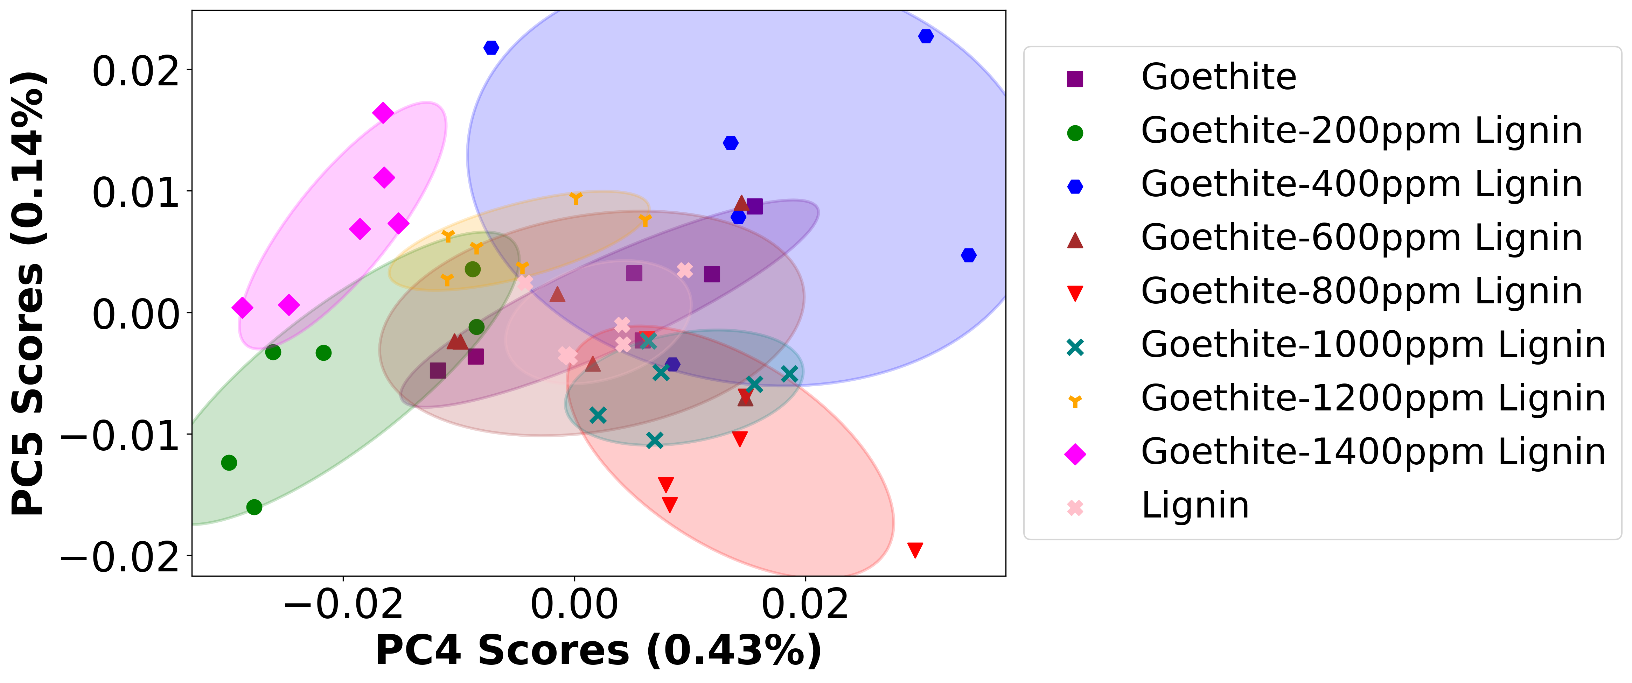

# Negative ion spectra, PCA analysis results -- PC1

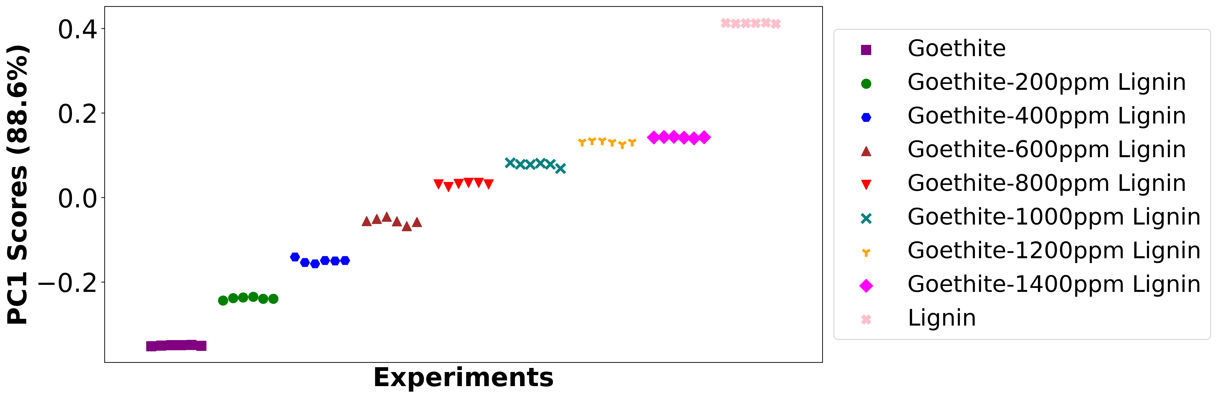

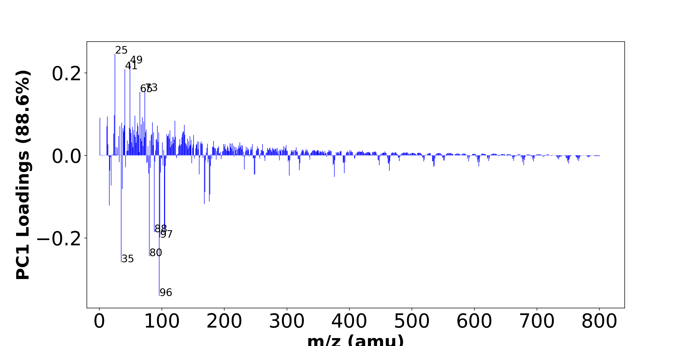

High score samples contain more:

* m/z 25 (C2H-), m/z 49 (C4H-), m/z 41 (C2OH-), m/z 73 (C6H-), m/z 65 (C4OH-), m/z 24 (C2-), m/z 57 (-), m/z 13 (CH-), m/z 69 (-), m/z 1 (H-), m/z 121 (-), m/z 71 (-), m/z 85 (-), m/z 36 (C3-), m/z 61 (SiO2H-), m/z 67 (-), m/z 136 (Si2O5-), m/z 40 (C2O-), m/z 93 (-), m/z 33 (O2H-,SH-),
* Hydrocarbon, SiOx, Benzene-contained organics

Low score samples contain more:

* m/z 96 (SO4-), m/z 35 (Cl-), m/z 80 (SO3-), m/z 97 (HSO4-,H2PO4-), m/z 88 (FeO2-), m/z 104 (-), m/z 105 (-), m/z 16 (O-), m/z 168 (-), m/z 176 (-), m/z 177 (-), m/z 169 (-), m/z 37 (37Cl-), m/z 19 (F-), m/z 376 (-), m/z 304 (-), m/z 248 (-), m/z 249 (-), m/z 160 (-), m/z 79 (PO3-),
* SOx

# Negative ion spectra, top positive loadings -- PC1

|  |  |  |  |  |  |  |
| --- | --- | --- | --- | --- | --- | --- |
| + loading | No. # | Unit Mass | Document Mass | Initial Peak Assignment | Measured Mass | Updated Peak Assignment |
|  | 1 | 25 | 25.0083 | C2H- |  |  |
|  | 2 | 49 | 49.0083 | C4H- |  |  |
|  | 3 | 41 | 41.0032 | C2OH- |  |  |
|  | 4 | 73 | 73.0083 | C6H- |  |  |
|  | 5 | 65 | 65.0032 | C4OH- |  |  |
|  | 6 | 24 | 24.0005 | C2- |  |  |
|  | 7 | 57 |  |  |  |  |
|  | 8 | 13 | 13.0084 | CH- |  |  |
|  | 9 | 69 |  |  |  |  |
|  | 10 | 1 | 1.0084 | H- |  |  |
|  | 11 | 121 |  |  |  |  |
|  | 12 | 71 |  |  |  |  |
|  | 13 | 85 |  |  |  |  |
|  | 14 | 36 | 36.0005 | C3- |  |  |
|  | 15 | 61 | 60.9751 | SiO2H- |  |  |
|  | 16 | 67 |  |  |  |  |
|  | 17 | 136 | 135.9289 | Si2O5- |  |  |
|  | 18 | 40 | 39.9954 | C2O- |  |  |
|  | 19 | 93 |  |  |  |  |
|  | 20 | 33 | 32.9982,32.9804 | O2H-,SH- |  |  |

# Negative ion spectra, top negative loadings -- PC1

|  |  |  |  |  |  |  |
| --- | --- | --- | --- | --- | --- | --- |
| - loading | No. # | Unit Mass | Document Mass | Initial Peak Assignment | Measured Mass | Updated Peak Assignment |
|  | 1 | 96 | 95.9522 | SO4- |  |  |
|  | 2 | 35 | 34.9694 | Cl- |  |  |
|  | 3 | 80 | 79.9573 | SO3- |  |  |
|  | 4 | 97 | 96.9601,96.9696 | HSO4-,H2PO4- |  |  |
|  | 5 | 88 | 87.9253 | FeO2- |  |  |
|  | 6 | 104 |  |  |  |  |
|  | 7 | 105 |  |  |  |  |
|  | 8 | 16 | 15.9955 | O- |  |  |
|  | 9 | 168 |  |  |  |  |
|  | 10 | 176 |  |  |  |  |
|  | 11 | 177 |  |  |  |  |
|  | 12 | 169 |  |  |  |  |
|  | 13 | 37 | 36.9664 | 37Cl- |  |  |
|  | 14 | 19 | 18.999 | F- |  |  |
|  | 15 | 376 |  |  |  |  |
|  | 16 | 304 |  |  |  |  |
|  | 17 | 248 |  |  |  |  |
|  | 18 | 249 |  |  |  |  |
|  | 19 | 160 |  |  |  |  |
|  | 20 | 79 | 78.959 | PO3- |  |  |

# Negative ion spectra, molecular information from PC1 loadings plot

* The major positive PC1 loadings are m/z 25 (C2H-), m/z 49 (C4H-), m/z 41 (C2OH-), m/z 73 (C6H-), m/z 65 (C4OH-), m/z 24 (C2-), m/z 57 (-), m/z 13 (CH-), m/z 69 (-), m/z 1 (H-), m/z 121 (-), m/z 71 (-), m/z 85 (-), m/z 36 (C3-), m/z 61 (SiO2H-), m/z 67 (-), m/z 136 (Si2O5-), m/z 40 (C2O-), m/z 93 (-), m/z 33 (O2H-,SH-), , indicating they are more observed in high PC1 score samples.
* The major negative PC1 loadings are m/z 96 (SO4-), m/z 35 (Cl-), m/z 80 (SO3-), m/z 97 (HSO4-,H2PO4-), m/z 88 (FeO2-), m/z 104 (-), m/z 105 (-), m/z 16 (O-), m/z 168 (-), m/z 176 (-), m/z 177 (-), m/z 169 (-), m/z 37 (37Cl-), m/z 19 (F-), m/z 376 (-), m/z 304 (-), m/z 248 (-), m/z 249 (-), m/z 160 (-), m/z 79 (PO3-), , indicating they are more observed in high PC1 score samples.
* Hydrocarbon signals, such as m/z 13 (CH-), m/z 24 (C2-), m/z 25 (C2H-), , are majorly found in positive loadings, indicating that high PC1 score samples contain more Hydrocarbon.
* SiOx signals, such as m/z 61 (SiO2H-), m/z 136 (Si2O5-), , are majorly found in positive loadings, indicating that high PC1 score samples contain more SiOx.
* Benzene-contained organics signals, such as m/z 49 (C4H-), m/z 36 (C3-), m/z 73 (C6H-), , are majorly found in positive loadings, indicating that high PC1 score samples contain more Benzene-contained organics.
* SOx signals, such as m/z 80 (SO3-), m/z 96 (SO4-), , are majorly found in negative loadings, indicating that high PC1 score samples contain more SOx.

# Negative ion spectra, PCA analysis results -- PC2

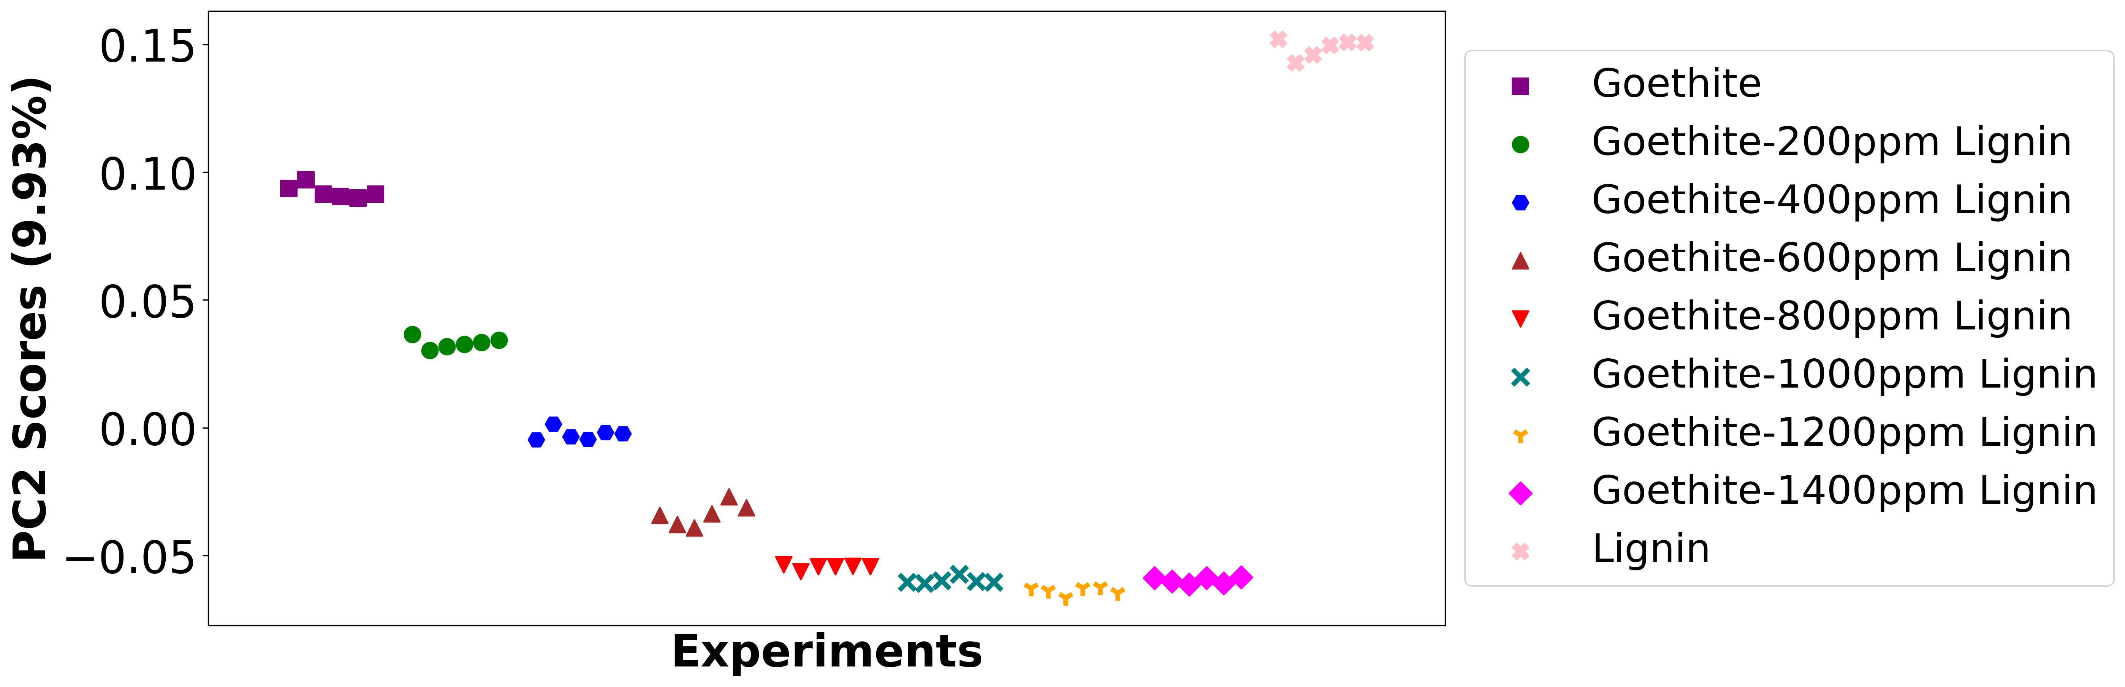

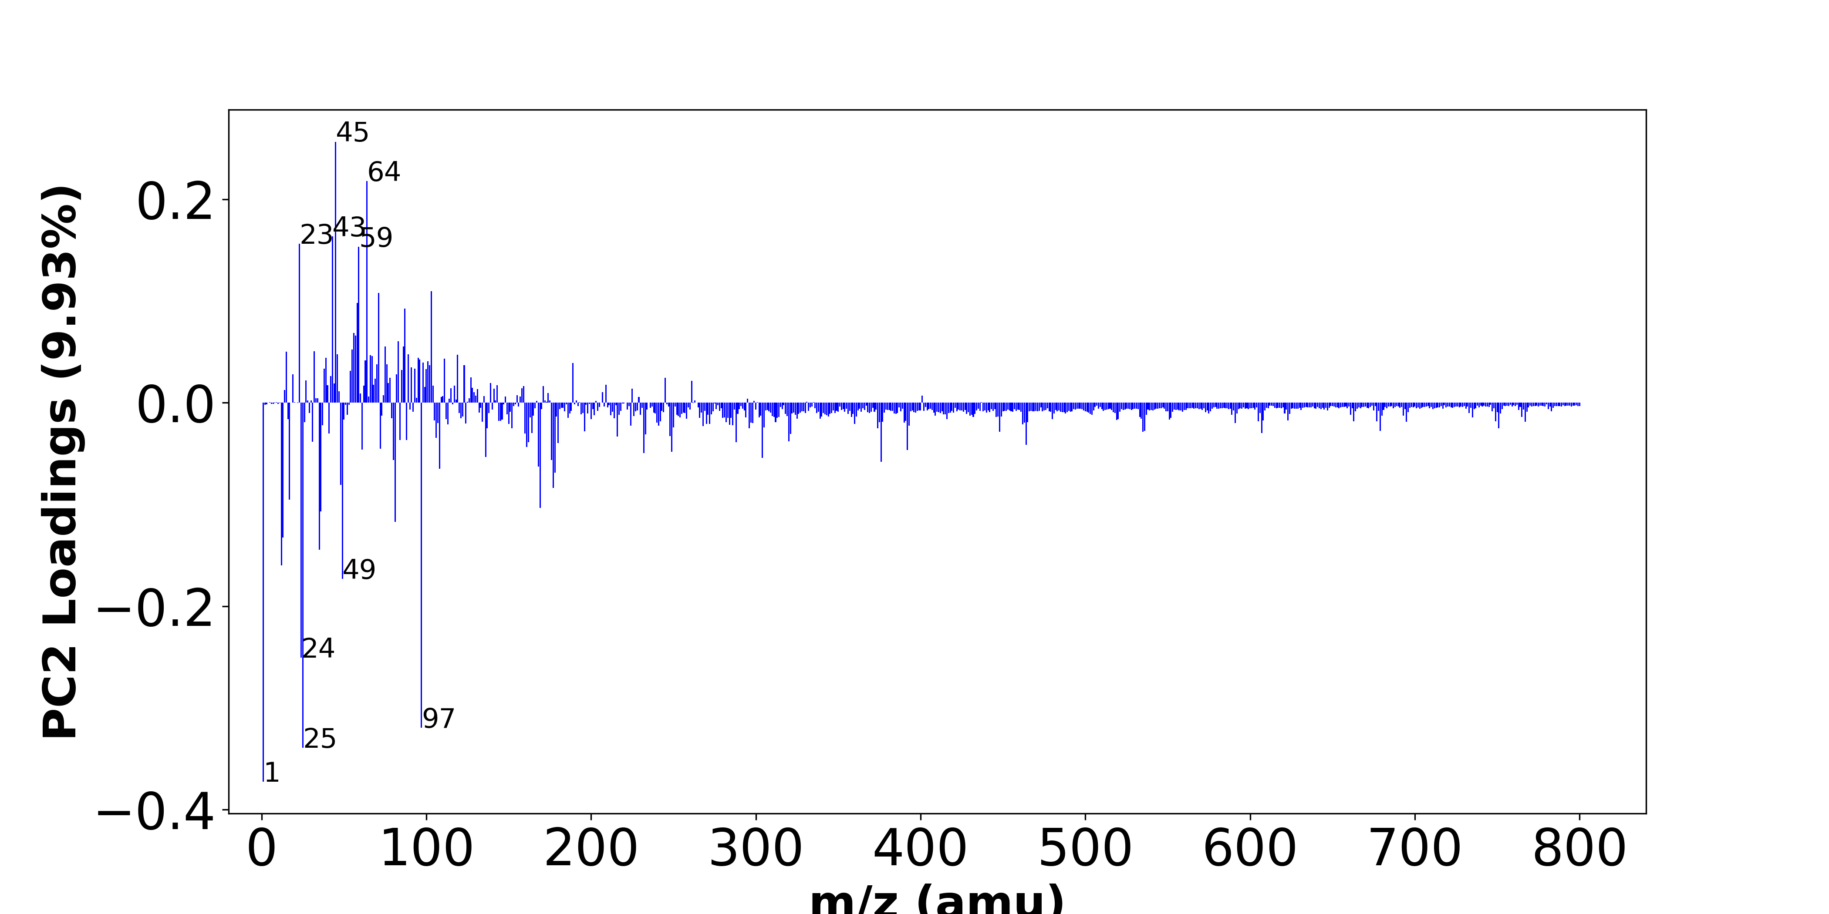

High score samples contain more:

* m/z 45 (CO2H-), m/z 64 (SO2-), m/z 43 (AlO-,BO2-), m/z 23 (-), m/z 59 (AlO2-), m/z 103 (-), m/z 71 (-), m/z 58 (-), m/z 87 (-), m/z 56 (-), m/z 57 (-), m/z 83 (-), m/z 86 (-), m/z 75 (-), m/z 55 (-), m/z 32 (O2-,S-), m/z 15 (-), m/z 46 (NO2-), m/z 89 (-), m/z 119 (NaSO4-),
* SOx, NOx, Organic acids

Low score samples contain more:

* m/z 1 (H-), m/z 25 (C2H-), m/z 97 (HSO4-,H2PO4-), m/z 24 (C2-), m/z 49 (C4H-), m/z 12 (C-), m/z 35 (Cl-), m/z 13 (CH-), m/z 81 (-), m/z 36 (C3-), m/z 169 (-), m/z 17 (OH-), m/z 177 (-), m/z 48 (C4-), m/z 178 (-), m/z 108 (-), m/z 168 (-), m/z 376 (-), m/z 176 (-), m/z 80 (SO3-),
* Hydrocarbon, Benzene-contained organics

# Negative ion spectra, top positive loadings -- PC2

|  |  |  |  |  |  |  |
| --- | --- | --- | --- | --- | --- | --- |
| + loading | No. # | Unit Mass | Document Mass | Initial Peak Assignment | Measured Mass | Updated Peak Assignment |
|  | 1 | 45 | 44.9982 | CO2H- |  |  |
|  | 2 | 64 | 63.9624 | SO2- |  |  |
|  | 3 | 43 | 42.977,42.9996 | AlO-,BO2- |  |  |
|  | 4 | 23 |  |  |  |  |
|  | 5 | 59 | 58.9719 | AlO2- |  |  |
|  | 6 | 103 |  |  |  |  |
|  | 7 | 71 |  |  |  |  |
|  | 8 | 58 |  |  |  |  |
|  | 9 | 87 |  |  |  |  |
|  | 10 | 56 |  |  |  |  |
|  | 11 | 57 |  |  |  |  |
|  | 12 | 83 |  |  |  |  |
|  | 13 | 86 |  |  |  |  |
|  | 14 | 75 |  |  |  |  |
|  | 15 | 55 |  |  |  |  |
|  | 16 | 32 | 31.9903,31.9726 | O2-,S- |  |  |
|  | 17 | 15 |  |  |  |  |
|  | 18 | 46 | 45.9934 | NO2- |  |  |
|  | 19 | 89 |  |  |  |  |
|  | 20 | 119 | 118.942 | NaSO4- |  |  |

# Negative ion spectra, top negative loadings -- PC2

|  |  |  |  |  |  |  |
| --- | --- | --- | --- | --- | --- | --- |
| - loading | No. # | Unit Mass | Document Mass | Initial Peak Assignment | Measured Mass | Updated Peak Assignment |
|  | 1 | 1 | 1.0084 | H- |  |  |
|  | 2 | 25 | 25.0083 | C2H- |  |  |
|  | 3 | 97 | 96.9601,96.9696 | HSO4-,H2PO4- |  |  |
|  | 4 | 24 | 24.0005 | C2- |  |  |
|  | 5 | 49 | 49.0083 | C4H- |  |  |
|  | 6 | 12 | 12.0005 | C- |  |  |
|  | 7 | 35 | 34.9694 | Cl- |  |  |
|  | 8 | 13 | 13.0084 | CH- |  |  |
|  | 9 | 81 |  |  |  |  |
|  | 10 | 36 | 36.0005 | C3- |  |  |
|  | 11 | 169 |  |  |  |  |
|  | 12 | 17 | 17.0032 | OH- |  |  |
|  | 13 | 177 |  |  |  |  |
|  | 14 | 48 | 48.0005 | C4- |  |  |
|  | 15 | 178 |  |  |  |  |
|  | 16 | 108 |  |  |  |  |
|  | 17 | 168 |  |  |  |  |
|  | 18 | 376 |  |  |  |  |
|  | 19 | 176 |  |  |  |  |
|  | 20 | 80 | 79.9573 | SO3- |  |  |

# Negative ion spectra, molecular information from PC2 loadings plot

* The major positive PC2 loadings are m/z 45 (CO2H-), m/z 64 (SO2-), m/z 43 (AlO-,BO2-), m/z 23 (-), m/z 59 (AlO2-), m/z 103 (-), m/z 71 (-), m/z 58 (-), m/z 87 (-), m/z 56 (-), m/z 57 (-), m/z 83 (-), m/z 86 (-), m/z 75 (-), m/z 55 (-), m/z 32 (O2-,S-), m/z 15 (-), m/z 46 (NO2-), m/z 89 (-), m/z 119 (NaSO4-), , indicating they are more observed in high PC2 score samples.
* The major negative PC2 loadings are m/z 1 (H-), m/z 25 (C2H-), m/z 97 (HSO4-,H2PO4-), m/z 24 (C2-), m/z 49 (C4H-), m/z 12 (C-), m/z 35 (Cl-), m/z 13 (CH-), m/z 81 (-), m/z 36 (C3-), m/z 169 (-), m/z 17 (OH-), m/z 177 (-), m/z 48 (C4-), m/z 178 (-), m/z 108 (-), m/z 168 (-), m/z 376 (-), m/z 176 (-), m/z 80 (SO3-), , indicating they are more observed in high PC2 score samples.
* SOx signals, such as m/z 64 (SO2-), , are majorly found in positive loadings, indicating that high PC2 score samples contain more SOx.
* NOx signals, such as m/z 46 (NO2-), , are majorly found in positive loadings, indicating that high PC2 score samples contain more NOx.
* Organic acids signals, such as m/z 45 (CO2H-), , are majorly found in positive loadings, indicating that high PC2 score samples contain more Organic acids.
* Hydrocarbon signals, such as m/z 12 (C-), m/z 13 (CH-), m/z 24 (C2-), m/z 25 (C2H-), , are majorly found in negative loadings, indicating that high PC2 score samples contain more Hydrocarbon.
* Benzene-contained organics signals, such as m/z 49 (C4H-), m/z 36 (C3-), , are majorly found in negative loadings, indicating that high PC2 score samples contain more Benzene-contained organics.

# Negative ion spectra, PCA analysis results -- PC3

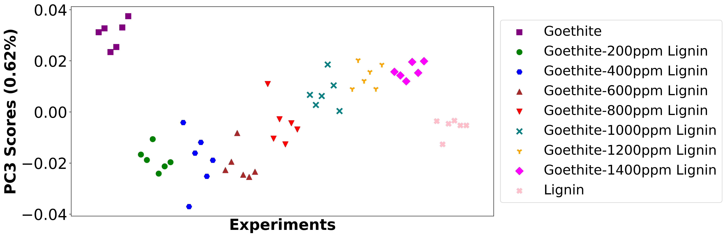

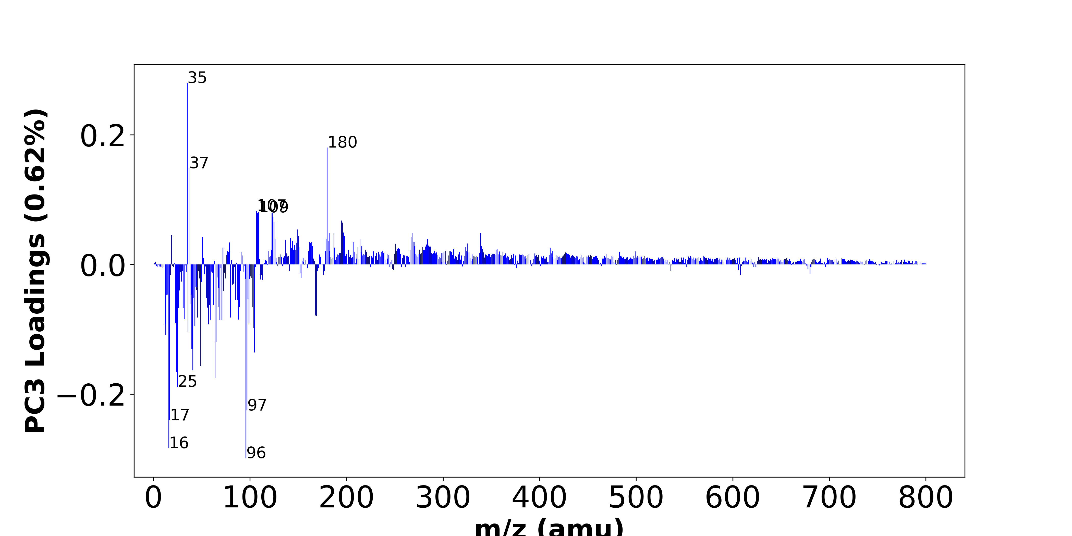

High score samples contain more:

* m/z 35 (Cl-), m/z 180 (-), m/z 37 (37Cl-), m/z 107 (-), m/z 109 (-), m/z 123 (-), m/z 108 (-), m/z 124 (-), m/z 195 (-), m/z 125 (-), m/z 196 (-), m/z 149 (-), m/z 197 (-), m/z 268 (-), m/z 339 (-), m/z 187 (-), m/z 182 (-), m/z 19 (F-), m/z 198 (-), m/z 150 (-),

Low score samples contain more:

* m/z 96 (SO4-), m/z 16 (O-), m/z 17 (OH-), m/z 97 (HSO4-,H2PO4-), m/z 25 (C2H-), m/z 64 (SO2-), m/z 24 (C2-), m/z 41 (C2OH-), m/z 49 (C4H-), m/z 105 (-), m/z 40 (C2O-), m/z 65 (C4OH-), m/z 13 (CH-), m/z 36 (C3-), m/z 104 (-), m/z 43 (AlO-,BO2-), m/z 57 (-), m/z 12 (C-), m/z 23 (-), m/z 99 (-),
* Hydrocarbon, SOx, Benzene-contained organics

# Negative ion spectra, top positive loadings -- PC3

|  |  |  |  |  |  |  |
| --- | --- | --- | --- | --- | --- | --- |
| + loading | No. # | Unit Mass | Document Mass | Initial Peak Assignment | Measured Mass | Updated Peak Assignment |
|  | 1 | 35 | 34.9694 | Cl- |  |  |
|  | 2 | 180 |  |  |  |  |
|  | 3 | 37 | 36.9664 | 37Cl- |  |  |
|  | 4 | 107 |  |  |  |  |
|  | 5 | 109 |  |  |  |  |
|  | 6 | 123 |  |  |  |  |
|  | 7 | 108 |  |  |  |  |
|  | 8 | 124 |  |  |  |  |
|  | 9 | 195 |  |  |  |  |
|  | 10 | 125 |  |  |  |  |
|  | 11 | 196 |  |  |  |  |
|  | 12 | 149 |  |  |  |  |
|  | 13 | 197 |  |  |  |  |
|  | 14 | 268 |  |  |  |  |
|  | 15 | 339 |  |  |  |  |
|  | 16 | 187 |  |  |  |  |
|  | 17 | 182 |  |  |  |  |
|  | 18 | 19 | 18.999 | F- |  |  |
|  | 19 | 198 |  |  |  |  |
|  | 20 | 150 |  |  |  |  |

# Negative ion spectra, top negative loadings -- PC3

|  |  |  |  |  |  |  |
| --- | --- | --- | --- | --- | --- | --- |
| - loading | No. # | Unit Mass | Document Mass | Initial Peak Assignment | Measured Mass | Updated Peak Assignment |
|  | 1 | 96 | 95.9522 | SO4- |  |  |
|  | 2 | 16 | 15.9955 | O- |  |  |
|  | 3 | 17 | 17.0032 | OH- |  |  |
|  | 4 | 97 | 96.9601,96.9696 | HSO4-,H2PO4- |  |  |
|  | 5 | 25 | 25.0083 | C2H- |  |  |
|  | 6 | 64 | 63.9624 | SO2- |  |  |
|  | 7 | 24 | 24.0005 | C2- |  |  |
|  | 8 | 41 | 41.0032 | C2OH- |  |  |
|  | 9 | 49 | 49.0083 | C4H- |  |  |
|  | 10 | 105 |  |  |  |  |
|  | 11 | 40 | 39.9954 | C2O- |  |  |
|  | 12 | 65 | 65.0032 | C4OH- |  |  |
|  | 13 | 13 | 13.0084 | CH- |  |  |
|  | 14 | 36 | 36.0005 | C3- |  |  |
|  | 15 | 104 |  |  |  |  |
|  | 16 | 43 | 42.977,42.9996 | AlO-,BO2- |  |  |
|  | 17 | 57 |  |  |  |  |
|  | 18 | 12 | 12.0005 | C- |  |  |
|  | 19 | 23 |  |  |  |  |
|  | 20 | 99 |  |  |  |  |

# Negative ion spectra, molecular information from PC3 loadings plot

* The major positive PC3 loadings are m/z 35 (Cl-), m/z 180 (-), m/z 37 (37Cl-), m/z 107 (-), m/z 109 (-), m/z 123 (-), m/z 108 (-), m/z 124 (-), m/z 195 (-), m/z 125 (-), m/z 196 (-), m/z 149 (-), m/z 197 (-), m/z 268 (-), m/z 339 (-), m/z 187 (-), m/z 182 (-), m/z 19 (F-), m/z 198 (-), m/z 150 (-), , indicating they are more observed in high PC3 score samples.
* The major negative PC3 loadings are m/z 96 (SO4-), m/z 16 (O-), m/z 17 (OH-), m/z 97 (HSO4-,H2PO4-), m/z 25 (C2H-), m/z 64 (SO2-), m/z 24 (C2-), m/z 41 (C2OH-), m/z 49 (C4H-), m/z 105 (-), m/z 40 (C2O-), m/z 65 (C4OH-), m/z 13 (CH-), m/z 36 (C3-), m/z 104 (-), m/z 43 (AlO-,BO2-), m/z 57 (-), m/z 12 (C-), m/z 23 (-), m/z 99 (-), , indicating they are more observed in high PC3 score samples.
* Hydrocarbon signals, such as m/z 12 (C-), m/z 13 (CH-), m/z 24 (C2-), m/z 25 (C2H-), , are majorly found in negative loadings, indicating that high PC3 score samples contain more Hydrocarbon.
* SOx signals, such as m/z 64 (SO2-), m/z 96 (SO4-), , are majorly found in negative loadings, indicating that high PC3 score samples contain more SOx.
* Benzene-contained organics signals, such as m/z 49 (C4H-), m/z 36 (C3-), , are majorly found in negative loadings, indicating that high PC3 score samples contain more Benzene-contained organics.

# Negative ion spectra, PCA analysis results -- PC4

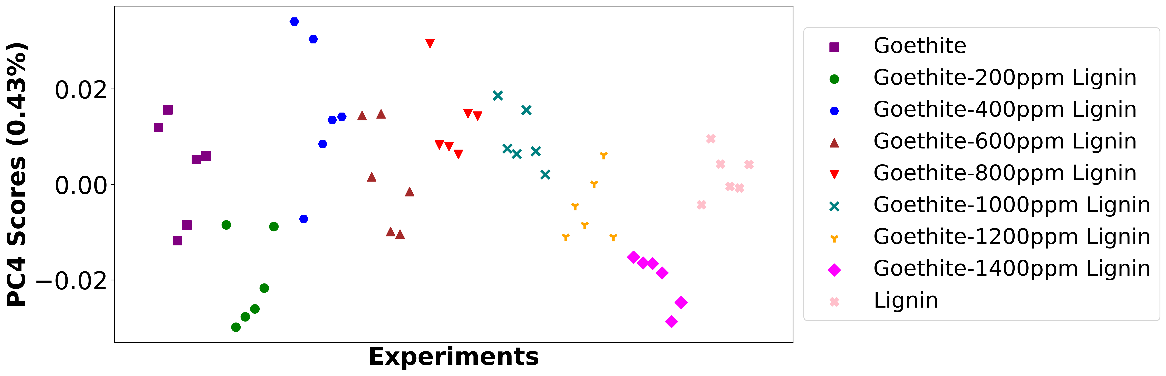

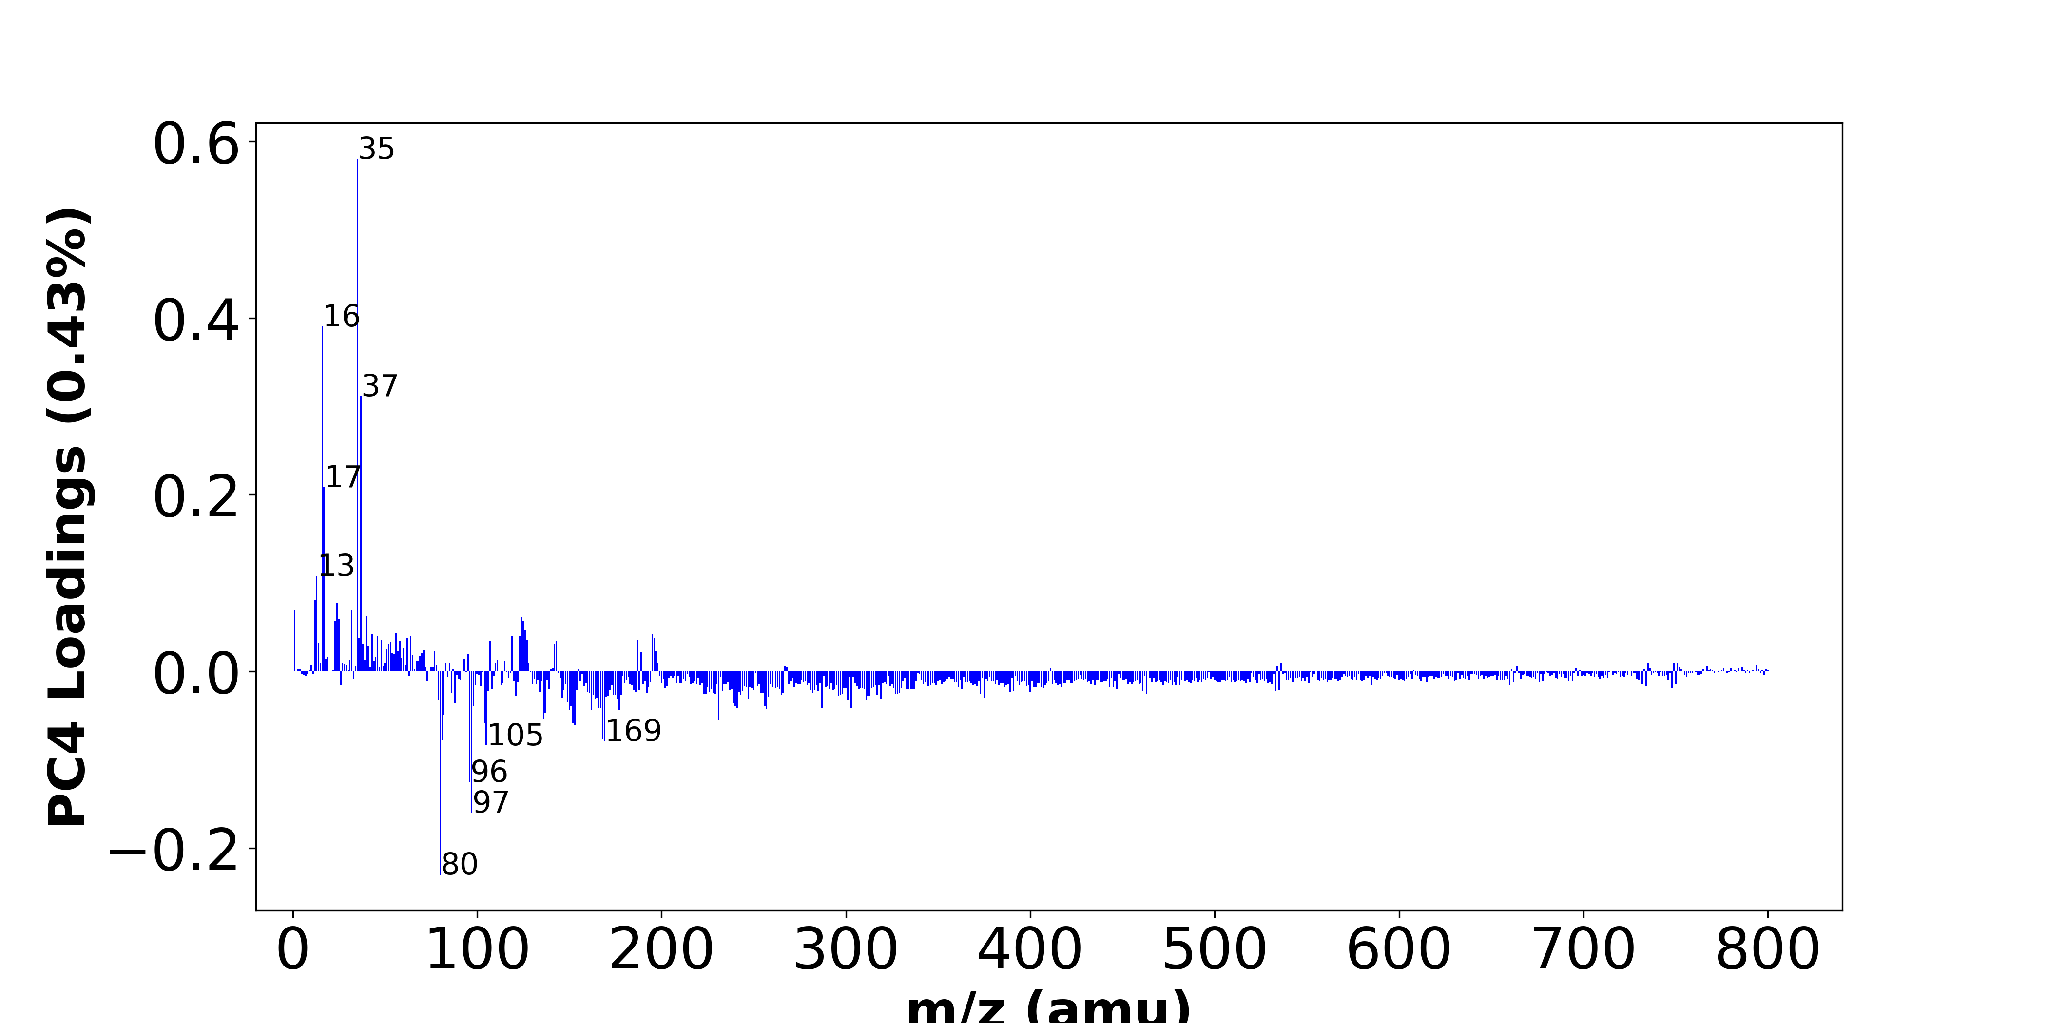

High score samples contain more:

* m/z 35 (Cl-), m/z 16 (O-), m/z 37 (37Cl-), m/z 17 (OH-), m/z 13 (CH-), m/z 12 (C-), m/z 24 (C2-), m/z 1 (H-), m/z 32 (O2-,S-), m/z 40 (C2O-), m/z 124 (-), m/z 25 (C2H-), m/z 23 (-), m/z 125 (-), m/z 126 (-), m/z 56 (-), m/z 195 (-), m/z 43 (AlO-,BO2-), m/z 119 (NaSO4-), m/z 46 (NO2-),
* Hydrocarbon, NOx

Low score samples contain more:

* m/z 80 (SO3-), m/z 97 (HSO4-,H2PO4-), m/z 96 (SO4-), m/z 105 (-), m/z 169 (-), m/z 81 (-), m/z 168 (-), m/z 153 (-), m/z 104 (-), m/z 152 (-), m/z 231 (-), m/z 136 (Si2O5-), m/z 82 (-), m/z 137 (Si2O5H-), m/z 162 (-), m/z 150 (-), m/z 177 (-), m/z 257 (-), m/z 166 (-), m/z 167 (-),
* SOx

# Negative ion spectra, top positive loadings -- PC4

|  |  |  |  |  |  |  |
| --- | --- | --- | --- | --- | --- | --- |
| + loading | No. # | Unit Mass | Document Mass | Initial Peak Assignment | Measured Mass | Updated Peak Assignment |
|  | 1 | 35 | 34.9694 | Cl- |  |  |
|  | 2 | 16 | 15.9955 | O- |  |  |
|  | 3 | 37 | 36.9664 | 37Cl- |  |  |
|  | 4 | 17 | 17.0032 | OH- |  |  |
|  | 5 | 13 | 13.0084 | CH- |  |  |
|  | 6 | 12 | 12.0005 | C- |  |  |
|  | 7 | 24 | 24.0005 | C2- |  |  |
|  | 8 | 1 | 1.0084 | H- |  |  |
|  | 9 | 32 | 31.9903,31.9726 | O2-,S- |  |  |
|  | 10 | 40 | 39.9954 | C2O- |  |  |
|  | 11 | 124 |  |  |  |  |
|  | 12 | 25 | 25.0083 | C2H- |  |  |
|  | 13 | 23 |  |  |  |  |
|  | 14 | 125 |  |  |  |  |
|  | 15 | 126 |  |  |  |  |
|  | 16 | 56 |  |  |  |  |
|  | 17 | 195 |  |  |  |  |
|  | 18 | 43 | 42.977,42.9996 | AlO-,BO2- |  |  |
|  | 19 | 119 | 118.942 | NaSO4- |  |  |
|  | 20 | 46 | 45.9934 | NO2- |  |  |

# Negative ion spectra, top negative loadings -- PC4

|  |  |  |  |  |  |  |
| --- | --- | --- | --- | --- | --- | --- |
| - loading | No. # | Unit Mass | Document Mass | Initial Peak Assignment | Measured Mass | Updated Peak Assignment |
|  | 1 | 80 | 79.9573 | SO3- |  |  |
|  | 2 | 97 | 96.9601,96.9696 | HSO4-,H2PO4- |  |  |
|  | 3 | 96 | 95.9522 | SO4- |  |  |
|  | 4 | 105 |  |  |  |  |
|  | 5 | 169 |  |  |  |  |
|  | 6 | 81 |  |  |  |  |
|  | 7 | 168 |  |  |  |  |
|  | 8 | 153 |  |  |  |  |
|  | 9 | 104 |  |  |  |  |
|  | 10 | 152 |  |  |  |  |
|  | 11 | 231 |  |  |  |  |
|  | 12 | 136 | 135.9289 | Si2O5- |  |  |
|  | 13 | 82 |  |  |  |  |
|  | 14 | 137 | 136.9368 | Si2O5H- |  |  |
|  | 15 | 162 |  |  |  |  |
|  | 16 | 150 |  |  |  |  |
|  | 17 | 177 |  |  |  |  |
|  | 18 | 257 |  |  |  |  |
|  | 19 | 166 |  |  |  |  |
|  | 20 | 167 |  |  |  |  |

# Negative ion spectra, molecular information from PC4 loadings plot

* The major positive PC4 loadings are m/z 35 (Cl-), m/z 16 (O-), m/z 37 (37Cl-), m/z 17 (OH-), m/z 13 (CH-), m/z 12 (C-), m/z 24 (C2-), m/z 1 (H-), m/z 32 (O2-,S-), m/z 40 (C2O-), m/z 124 (-), m/z 25 (C2H-), m/z 23 (-), m/z 125 (-), m/z 126 (-), m/z 56 (-), m/z 195 (-), m/z 43 (AlO-,BO2-), m/z 119 (NaSO4-), m/z 46 (NO2-), , indicating they are more observed in high PC4 score samples.
* The major negative PC4 loadings are m/z 80 (SO3-), m/z 97 (HSO4-,H2PO4-), m/z 96 (SO4-), m/z 105 (-), m/z 169 (-), m/z 81 (-), m/z 168 (-), m/z 153 (-), m/z 104 (-), m/z 152 (-), m/z 231 (-), m/z 136 (Si2O5-), m/z 82 (-), m/z 137 (Si2O5H-), m/z 162 (-), m/z 150 (-), m/z 177 (-), m/z 257 (-), m/z 166 (-), m/z 167 (-), , indicating they are more observed in high PC4 score samples.
* Hydrocarbon signals, such as m/z 12 (C-), m/z 13 (CH-), m/z 24 (C2-), m/z 25 (C2H-), , are majorly found in positive loadings, indicating that high PC4 score samples contain more Hydrocarbon.
* NOx signals, such as m/z 46 (NO2-), , are majorly found in positive loadings, indicating that high PC4 score samples contain more NOx.
* SOx signals, such as m/z 80 (SO3-), m/z 96 (SO4-), , are majorly found in negative loadings, indicating that high PC4 score samples contain more SOx.

# Negative ion spectra, PCA analysis results -- PC5

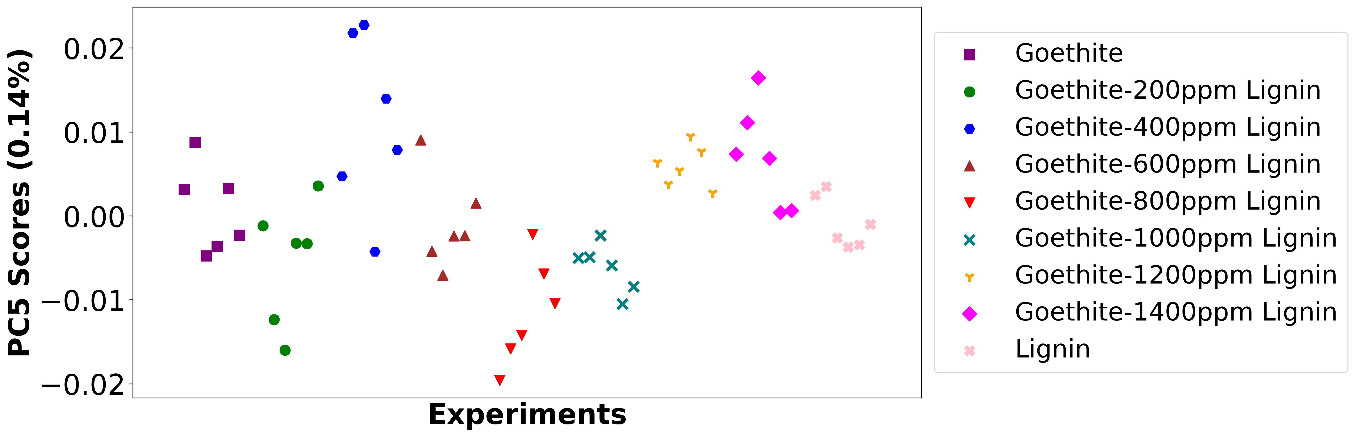

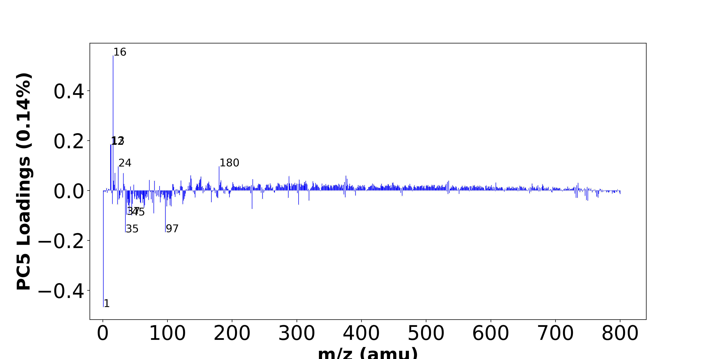

High score samples contain more:

* m/z 16 (O-), m/z 13 (CH-), m/z 12 (C-), m/z 180 (-), m/z 24 (C2-), m/z 19 (F-), m/z 32 (O2-,S-), m/z 136 (Si2O5-), m/z 376 (-), m/z 288 (-), m/z 152 (-), m/z 137 (Si2O5H-), m/z 378 (-), m/z 151 (-), m/z 232 (-), m/z 304 (-), m/z 72 (-), m/z 150 (-), m/z 183 (-), m/z 121 (-),
* Hydrocarbon

Low score samples contain more:

* m/z 1 (H-), m/z 35 (Cl-), m/z 97 (HSO4-,H2PO4-), m/z 45 (CO2H-), m/z 37 (37Cl-), m/z 41 (C2OH-), m/z 79 (PO3-), m/z 231 (-), m/z 64 (SO2-), m/z 106 (-), m/z 99 (-), m/z 104 (-), m/z 65 (C4OH-), m/z 40 (C2O-), m/z 303 (-), m/z 23 (-), m/z 124 (-), m/z 15 (-), m/z 46 (NO2-), m/z 59 (AlO2-),
* SOx, POx, NOx, Organic acids

# Negative ion spectra, top positive loadings -- PC5

|  |  |  |  |  |  |  |
| --- | --- | --- | --- | --- | --- | --- |
| + loading | No. # | Unit Mass | Document Mass | Initial Peak Assignment | Measured Mass | Updated Peak Assignment |
|  | 1 | 16 | 15.9955 | O- |  |  |
|  | 2 | 13 | 13.0084 | CH- |  |  |
|  | 3 | 12 | 12.0005 | C- |  |  |
|  | 4 | 180 |  |  |  |  |
|  | 5 | 24 | 24.0005 | C2- |  |  |
|  | 6 | 19 | 18.999 | F- |  |  |
|  | 7 | 32 | 31.9903,31.9726 | O2-,S- |  |  |
|  | 8 | 136 | 135.9289 | Si2O5- |  |  |
|  | 9 | 376 |  |  |  |  |
|  | 10 | 288 |  |  |  |  |
|  | 11 | 152 |  |  |  |  |
|  | 12 | 137 | 136.9368 | Si2O5H- |  |  |
|  | 13 | 378 |  |  |  |  |
|  | 14 | 151 |  |  |  |  |
|  | 15 | 232 |  |  |  |  |
|  | 16 | 304 |  |  |  |  |
|  | 17 | 72 |  |  |  |  |
|  | 18 | 150 |  |  |  |  |
|  | 19 | 183 |  |  |  |  |
|  | 20 | 121 |  |  |  |  |

# Negative ion spectra, top negative loadings -- PC5

|  |  |  |  |  |  |  |
| --- | --- | --- | --- | --- | --- | --- |
| - loading | No. # | Unit Mass | Document Mass | Initial Peak Assignment | Measured Mass | Updated Peak Assignment |
|  | 1 | 1 | 1.0084 | H- |  |  |
|  | 2 | 35 | 34.9694 | Cl- |  |  |
|  | 3 | 97 | 96.9601,96.9696 | HSO4-,H2PO4- |  |  |
|  | 4 | 45 | 44.9982 | CO2H- |  |  |
|  | 5 | 37 | 36.9664 | 37Cl- |  |  |
|  | 6 | 41 | 41.0032 | C2OH- |  |  |
|  | 7 | 79 | 78.959 | PO3- |  |  |
|  | 8 | 231 |  |  |  |  |
|  | 9 | 64 | 63.9624 | SO2- |  |  |
|  | 10 | 106 |  |  |  |  |
|  | 11 | 99 |  |  |  |  |
|  | 12 | 104 |  |  |  |  |
|  | 13 | 65 | 65.0032 | C4OH- |  |  |
|  | 14 | 40 | 39.9954 | C2O- |  |  |
|  | 15 | 303 |  |  |  |  |
|  | 16 | 23 |  |  |  |  |
|  | 17 | 124 |  |  |  |  |
|  | 18 | 15 |  |  |  |  |
|  | 19 | 46 | 45.9934 | NO2- |  |  |
|  | 20 | 59 | 58.9719 | AlO2- |  |  |

# Negative ion spectra, molecular information from PC5 loadings plot

* The major positive PC5 loadings are m/z 16 (O-), m/z 13 (CH-), m/z 12 (C-), m/z 180 (-), m/z 24 (C2-), m/z 19 (F-), m/z 32 (O2-,S-), m/z 136 (Si2O5-), m/z 376 (-), m/z 288 (-), m/z 152 (-), m/z 137 (Si2O5H-), m/z 378 (-), m/z 151 (-), m/z 232 (-), m/z 304 (-), m/z 72 (-), m/z 150 (-), m/z 183 (-), m/z 121 (-), , indicating they are more observed in high PC5 score samples.
* The major negative PC5 loadings are m/z 1 (H-), m/z 35 (Cl-), m/z 97 (HSO4-,H2PO4-), m/z 45 (CO2H-), m/z 37 (37Cl-), m/z 41 (C2OH-), m/z 79 (PO3-), m/z 231 (-), m/z 64 (SO2-), m/z 106 (-), m/z 99 (-), m/z 104 (-), m/z 65 (C4OH-), m/z 40 (C2O-), m/z 303 (-), m/z 23 (-), m/z 124 (-), m/z 15 (-), m/z 46 (NO2-), m/z 59 (AlO2-), , indicating they are more observed in high PC5 score samples.
* Hydrocarbon signals, such as m/z 12 (C-), m/z 13 (CH-), m/z 24 (C2-), , are majorly found in positive loadings, indicating that high PC5 score samples contain more Hydrocarbon.
* SOx signals, such as m/z 64 (SO2-), , are majorly found in negative loadings, indicating that high PC5 score samples contain more SOx.
* POx signals, such as m/z 79 (PO3-), , are majorly found in negative loadings, indicating that high PC5 score samples contain more POx.
* NOx signals, such as m/z 46 (NO2-), , are majorly found in negative loadings, indicating that high PC5 score samples contain more NOx.
* Organic acids signals, such as m/z 45 (CO2H-), , are majorly found in negative loadings, indicating that high PC5 score samples contain more Organic acids.